Auxiliary Metering for Solar (PV) + Energy Storage Systems (ESS) Interconnections Summary:

June 2020

Background:

Initial discussions on the auxiliary metering topic in late 2019 lead to DPS supporting the Joint Utilities’ position to require a separate auxiliary meter at the expense of the customer / applicant to record auxiliary loads due to concerns with metering accuracy when utilizing a single meter to measure both auxiliary loads from ESS and maximum generation output from PV. After a February 27, 2020 letter from the Industry disputing the initial position on this topic, the ITWG began in-depth discussions on the need / requirement to provide an additional meter to account and read auxiliary loads (such as HVAC and other small loads) on PV+ESS interconnection projects.

The Industry says an additional service and meter can be costly, and the loads are very small compared to the actual load even when the associated PV system is not generating. The Utilities say that these small loads are not accurately recorded by the main meters because the current transformer (CT’s) that supply the meter have limitations at low load levels and this inaccuracy is significant enough to require separate metering. The loads must be accurately captured so all customers are not impacted.  This issue has arisen with the development of hybrid type interconnection projects and auxiliary loads as part of existing PV projects and that these metering inaccuracies are not of concern and considered small and insignificant.  However, the ESS component of a PV+ESS projects has additional and significant HVAC loads that the Utilities believe must be addressed.

Several positions papers were presented including:

* “2/6/2020 ITWG Industry Response Auxiliary Metering for ESS Projects,” memo by the New York Solar Energy Industries Association & ITWG Industry Group to NYSDPS, dated February 27, 2020
* “2/27/2020 ITWG Industry Response - Auxiliary Metering for ESS Projects,” confidential memo by Joint Utilities of New York – Interconnection Technical Working Group, dated April 24, 2020
* “ITWG Industry Response - Auxiliary Metering for ESS Projects,” memo by New York Solar Energy Industries Association & ITWG Industry Group to NYSDPS, dated March 31, 2020
* “ITWG Industry Position Summary - Auxiliary Metering for ESS Projects,” email by New York Solar Energy Industries Association & ITWG Industry Group to NYSDPS, dated May 27, 2020.

The main technical contention is the accuracy difference between:

* A single service meter at the PV+BESS plant
* Additional auxiliary meter at the plant, i.e., a two-meter configuration.

Sample configurations for the single-meter and two-meter are shown in Figure 1-1 and Figure 1-2, respectively.



**Figure 1-1: Sample Configuration for a Single-Meter PV+BESS Installation**



**Figure 1-2: Sample Configuration for a Two-Meter PV+BESS Installation**

**1.2. Meter and Instrument Transformer Accuracy**

Discussion:

This topic was heavily debated from each side and both provided technical and relevant justifications for their positions. After several discussions in the ITWG meetings over the first and second quarter of 2020, and the inability of Industry and the Joint Utilities to reach consensus position, the Department of Public Service (DPS) Staff was determined to reach a final decision. DPS Staff commissioned its independent technical ITWG consultant Pterra to review this topic, including and all associated material, and then provide its recommendation to DPS Staff and the ITWG. After a thorough review of all documentation and position papers provided by each party, review of the Pterra analysis and discussion with NYSERDA; DPS made a final determination.

Below are some Sample configurations from the Pterra analysis for sub-metering are shown in Figure 1-3 and Figure 1-4, respectively.



**Figure 1-3: Sample Configuration for a Single Sub-Meter Installation**

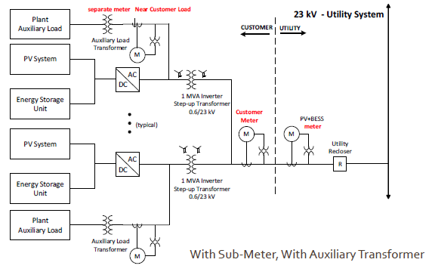

**Figure 1-4: Sample Configuration for a Dual Sub-Meter Installation**

Conclusion:

Based on all material and information provided on the topic, DPS determined that although both sides provided technically relevant justifications for their positions, the level of inaccuracies and small amount of potential discrepancies caused by metering these loads utilizing only one meter did not warrant the separate auxiliary meter service and associated costs. Utilities note that it may be necessary to require a separate meter or service for ESS loads for other purposes, such as to verify ESS control schemes. DPS communicated this determination to the ITWG at the 6/11/20 meeting and should be considered in effect as of that date.