Frequently Asked Questions about Smart Inverters

Joint Utilities of New York

What is a smart inverter?

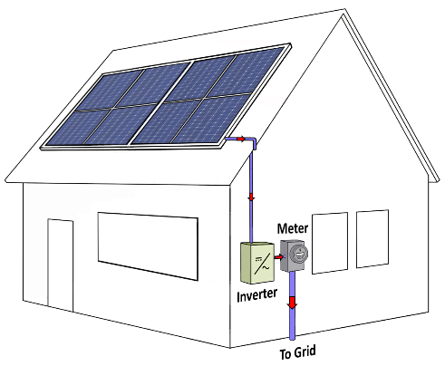
All inverters serve the important function of interfacing newer direct current (DC) equipment, like solar panels and batteries, with traditional alternating current (AC) utility grids. Inverters of the past would only be capable of feeding power from generators like solar directly to the grid. Newer smart inverters have been developed to operate in both directions and can now dynamically respond to any abnormal grid conditions. By doing so, they increase the overall safety, reliability, and security for the entire system. Through sophisticated sensing and power electronics, smart inverters make decisions autonomously on how to best keep the grid stable and reliable. These devices are growing in importance as distributed energy resources (DERs) such as solar, fuel cells, and batteries continue to proliferate.
Most importantly, smart inverters dynamically provide grid support during voltage and frequency disturbances, and offer the capability for secure communications with other local or utility controllers. For instance, during an abnormally high or low voltage or frequency event, instead of immediately going offline, a smart inverter can be programmed to rapidly switch into standby mode and “ride through” the event, turning off only if the disturbance lasts longer than anticipated. This allows DERs to help maintain the balance between load and generation, while also allowing customers to continue exporting for longer.
In addition to riding through voltage and frequency disturbances, smart inverters can also improve the reliability of the grid by producing or absorbing reactive power along with real power. By tuning the reactive power levels on the grid, smart inverters can help suppress some of the large voltage fluctuations DERs create on the system and avoid unintended impacts to utility and customer equipment.

What is IEEE Standard 1547 – 2018? What are UL 1741 Supplement A (SA) and Supplement B (SB)?

The Institute of Electrical and Electronics Engineers (IEEE) is a standards making organization whose members helped draft 1547-2018 since 2014. This standard sets the minimum capabilities for DER interfacing equipment (e.g. smart inverters) to connect to the grid. It sets the operating ranges the equipment must be capable of providing, in terms of system protection settings, voltage and frequency support, reactive power support, and real power exchange.
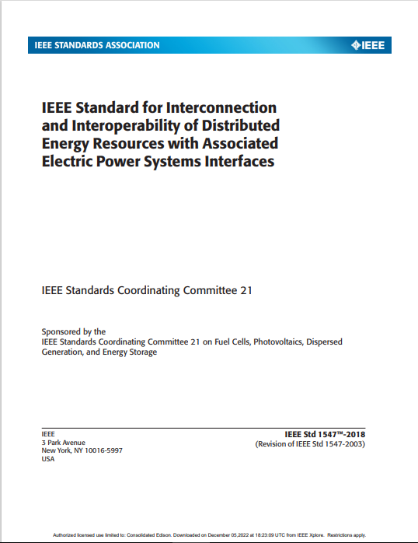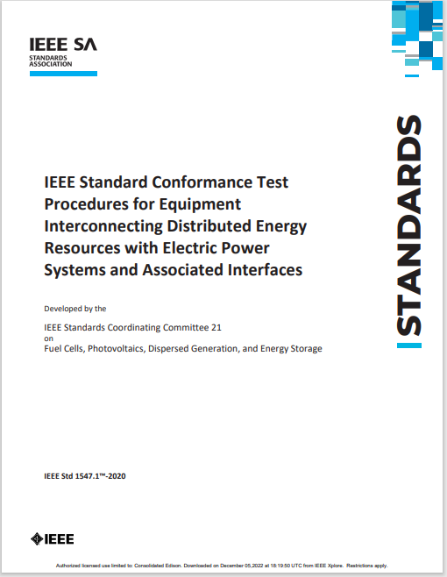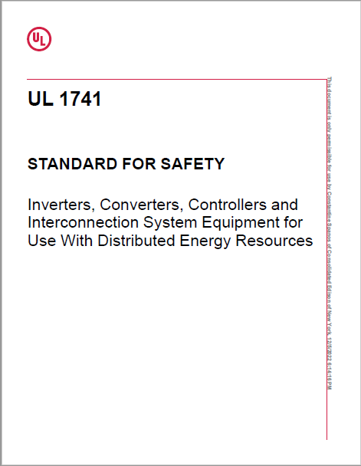
IEEE 1547-2018
Interconnection Requirements
- System requirements for voltage and frequency
- System protection & grounding
- Operation of DERs as an island
UL1741 and A, B Supplements
Equipment Standard
- Provides the basis for UL listing of an inverter
- UL 1741SB inverters uses 1547.1 testing
- Covers inverter construction, ratings, markings, and protection
IEEE 1547.1-2020
System Testing Requirements
- System testing for voltage and frequency responses
- Device surge current testing
- Harmonics testing
- Islanding testing

Underwriters Libraries (UL) a product testing and certification business, developed safety standard 1741 for inverters, converters, controllers, and interconnection system equipment for use with distributed energy resource. UL 1741 was revised in 2016 to incorporate Supplement A (SA), which allowed manufacturers to manufacture and list inverters to UL1741SA, providing enhanced grid support functionality. UL1741SA preceded the publication of IEEE 1547-2018 and the associated test standard, IEEE 1547.1. As such, it was based on the requirements set forth in California Rule 21 and allowed the Independent System Operator for New England (ISO NE) to update their required generator settings and meet interim needs. The latest UL 1741 Supplement B (SB) was added in 2021 and conforms to the testing requirements set forth in the 2020 revision to 1547.1. With the release of UL 1741 SB, manufacturers can now produce UL1741 SB listed inverters. By doing so, this ensures devices have been tested according to the latest IEEE standards, and can safely provide the required grid-support functionality.

How do these standards and guidelines contribute to the safe and reliable operation of the electric power system?

Technical specifications and requirements provide the basis for the use of safe and reliable equipment for any interconnection. Having appropriate inverter listings, such as UL 1741 SB ensures that the same inverter certification process was conducted by one of the many Nationally Recognized Testing Laboratories (NRTL) across the country. The test and grid standards also provide utilities a consistent means of specifying the required performance of customer inverter equipment. As such, standards enable a safer, smarter, and more streamlined interconnection process, while at the same time allowing for changes in the future by ensuring communications interoperability between customer equipment and the utility.

What benefits do smart inverters provide to the electric power system?

The key to a stable grid is maintaining a consistent voltage and frequency, and smart inverters have the capability of monitoring and adjusting output to better accommodate grid changes in voltage and frequency. As such, smart inverters not only increase the available hosting capacity of DERs, but also make the electric grid more resilient, flexible, and reliable. For instance, consider a scenario where many inverters trip offline. Such an event could result in significant instability in grid voltage and frequency that can lead to a system-wide blackout or brownout. By riding-through small disturbances, smart inverters can ensure wide-scale deployments of DERs won’t contribute to system instability in the future.
DERs injecting power during times of low usage raise the voltage on the system to levels that can impact utility and customer equipment. Here, smart inverters provide the intelligence to modify active and reactive power output to prevent voltage extremes. In doing so, upgrades to utility substations and any downstream equipment may not be required, saving all customers money on their electricity bills and allowing more DER to come online in the future.
Additionally, smart inverters certified to UL 1741 ensure that any power generated will be at utility-grade power quality, meaning any harmonics created from the inverter won’t impact other customers’ appliances.

How will I be impacted by the Joint Utilities’ requirement, starting January 1, 2023, for all inverter-based resources to use IEEE Standard 1547-2018 compliant and UL 1741 SB certified inverters?

Starting January 1st 2023, utilities in NY will increasingly require all new solar and storage installations be configured to their preferred IEEE 1547-2018 set points. In addition, the New York State Standardized Interconnection Requirements document (NYS SIR) will be modified to require the use of UL 1741 SB listed inverters. Depending on your utility provider, the deadline for the adoption of SB inverters may vary. Appropriate inverter certifications and set points will be verified during DER commissioning, prior to utilities granting any permission to operate. As such, it is important to check your local utility’s requirements regarding IEEE 1547 set points and UL 1741 device listings when considering a new interconnection in 2023 and afterward.
Any preexisting inverter installations would not need to update their hardware or software to comply with this new requirement, and the requirements will not be retroactive.

What are the different performance categories for smart inverters, and what do these mean?

IEEE 1547-2018 specifies two performance categories for interfacing equipment during normal operation, “A” and “B”. These categories set different minimum reactive power requirements that the equipment should be capable of providing to assist with voltage regulation:
- Equipment designed to Category A meet the basic performance requirements of the electric power system, and are “reasonably attainable by all state-of-the-art DER technologies”. This category is mostly suitable for synchronous machines having interfacing equipment with limited dynamic functionality.
- Equipment designed to Category B provides reactive power performance in excess of Category A to support the installation of high quantities of DER like solar and batteries. Category B is attainable by most smart inverters.
In addition to the normal performance capabilities described above, IEEE 1547 also defines the degree to which the equipment contributes to maintaining system reliability during an abnormal condition from lowest (Category I) to highest (Category III). Most utilities will require smart inverters be configured to Category II or III settings, but the decision will ultimately depend on the quantity of already connected DER and bulk system reliability needs.

Where can I find additional information about smart inverters?

Some additional information has been provided by the following organizations:
- Smart Inverter Interoperability Standards and Open Testing Framework to Support High-Penetration Distributed Photovoltaics and Storage | California Energy Commission
- Impact of IEEE 1547 Standard on Smart Inverters and the Applications in Power Systems (nrel.gov)
- Smart Inverter Update: New IEEE 1547 Standards and State Implementation Efforts - Interstate Renewable Energy Council (IREC) (irecusa.org)
- IEEE Smart Energy Webinar | IEEE Standards Association

Where can I find more information about each NY utility’s technical standards and requirements?

Each NY utility’s interconnection requirements and smart inverter setpoints can be found in the following links:
- Interconnection Resources | Joint Utilities of New York
- Utility Smart Inverter Settings | NY DPS Interconnection Technical Working Group

